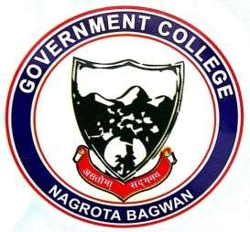
GOVERNMENT COLLEGE
NAGROTA BAGWAN
Distt. Kangra (H.P.)-176047
Tel.: 01892-251177
EMAILID: gcnagrotabagwan@gmail.com

Web Links of List of Initiatives taken during 2022-23

- Detail of Sports Activities
http://gdcnb.org/sports/

- Detail of Red Ribbon Club Activities
http://gdcnb.org/red-ribbon-club/

- Detail of NSS Activities
http://gdcnb.org/nss/

- Detail of Rovers and Rangers Activities
http://gdcnb.org/rovers-and-rangers/

- Detail of ECO Club Activities
http://gdcnb.org/eco-club/
- Detail of Yoga, Health and Fitness Club Activities
http://gdcnb.org/yoga-health-and-fitness-club/

- Detail of Road Safety Club
http://gdcnb.org/road-safety-club/

- Detail of Women Grievances & Redressal Cell
http://gdcnb.org/wp-content/uploads/2024/04/Annual-Gender-Sensitization-Action-Plan-for-the-Session-2022-23.pdf

- Detail of Extension Activities 2022-23
http://gdcnb.org/departmental-activities/

